Preparation of Papers for International Journal of Applied Technology and Leadership (IJATL)

First A. Author, Second B. Author, and Third C. Author

Abstract—The electronic file of your paper will be formatted further at International Journal of Applied Technology and Leadership. Define all symbols used in the abstract. Do not cite references in the abstract.

Index Terms—Three key words or phrases in alphabetical order, separated by commas.

Introduction
Highlight a section that you will designate with a certain style, then select the appropriate name on the style menu. The style will adjust your fonts and line spacing. Do not change any of the font sizes or line spacing. Use italics for emphasis; never underline.
Inserting images in Word, position the cursor at the insertion point and either use Insert | Picture | From File or copy the image to the Windows clipboard and then Edit | Paste Special | Picture (with “Float over text” unchecked).
INTERNATIONAL JOURNAL OF APPLIED TECHNOLOGY AND LEADERSHIP reserves the right to do the final formatting of your paper.

Procedure for Submission

The Review Stage
Submit your manuscript via e mail for review.

The Final Stage
When you submit your final version, after your paper has been accepted, prepare it in two-column format, including figures and tables.

All Figures
As said, to insert images in Word, position the cursor at the insertion point and either use Insert | Picture | From File or copy the image to the Windows clipboard and then Edit | Paste Special | Picture (with “Float over text” unchecked).
The authors of the accepted manuscripts will be given a copyright form and the form should accompany your final submission.

Math
If you are using Word, use either the Microsoft Equation Editor or the MathType add-on (http://www.mathtype.com) for equations in your paper (Insert | Object | Create New | Microsoft Equation or MathType Equation). “Float over text” should not be selected.

Units
Use SI units, English units may be used as secondary units (in parentheses). This applies to papers in data storage.
The SI unit for magnetic field strength H is A/m. However, if you wish to use units of T, either refer to magnetic flux density B or magnetic field strength symbolized as µ₀H. Use the center dot to separate compound units, e.g., “A·m².”

Helpful Hints

Figures and Tables
Because the final formatting of your paper is limited in scale, you need to position figures and tables at the top and bottom of each column. Large figures and tables may span both columns. Place figure captions below the figures; place table titles above the tables. If your figure has two parts, include the labels “(a)” and “(b)” as part of the artwork. Please verify that the figures and tables you mention in the text actually exist. Do not put borders around the outside of your figures. Use the abbreviation “Fig.” even at the beginning of a sentence. Do not abbreviate “Table.” Tables are numbered with Roman numerals.
Include a note with your final paper indicating that you request color printing. Do not use color unless it is necessary for the proper interpretation of your figures.
Figure axis labels are often a source of confusion. Use words rather than symbols.

TABLE I: The Arrangement of Channels

Channels | Group 1 | Group 2 | … | Group c
Main channel | Channel 1 | Channel 2 | … | Channel c
Assistant channel | Channel 2 | Channel 3 | … | Channel 1

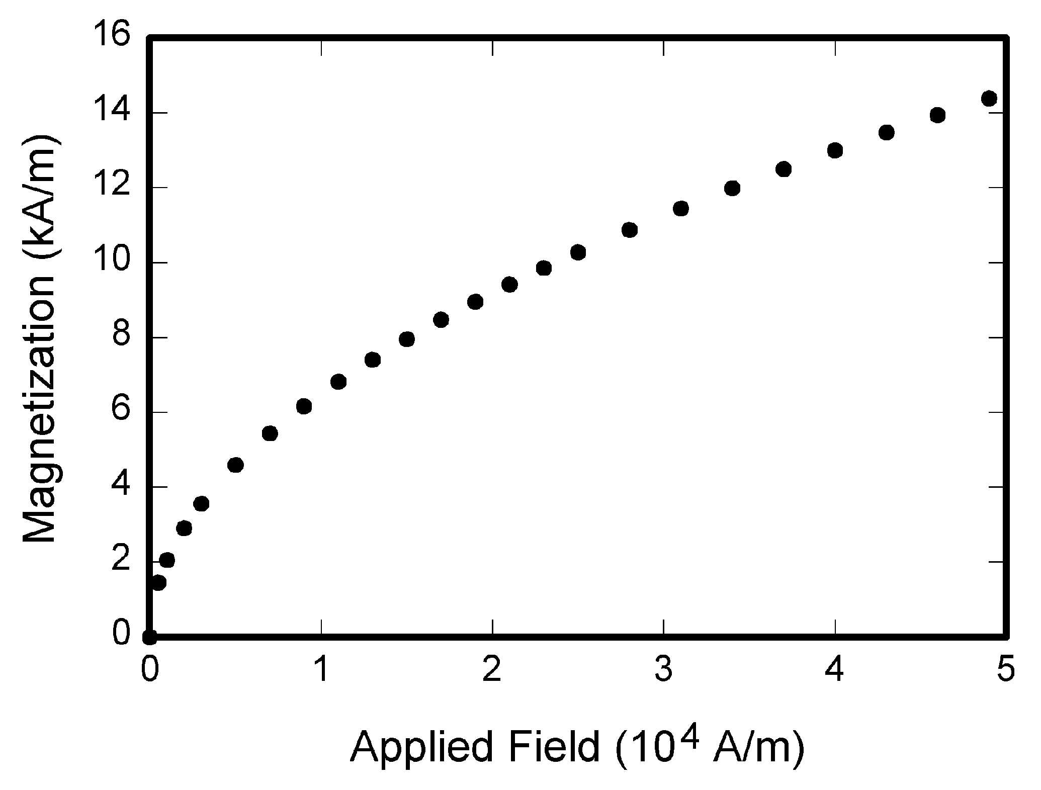
Fig. 1. Magnetization as a function of applied field.

References
Number citations consecutively in square brackets [1]. The sentence punctuation follows the brackets [2]. Multiple references [2], [3] are each numbered with separate brackets [1]–[3]. When citing a section in a book, please give the relevant page numbers [2]. In sentences, refer simply to the reference number, as in [3]. Do not use “Ref. [3]” or “reference [3]” except at the beginning of a sentence: “Reference [3] shows ... .” Number footnotes separately in superscripts (Insert | Footnote). Place the actual footnote at the bottom of the column in which it is cited; do not put footnotes in the reference list (endnotes). Use letters for table footnotes (see Table I).
Please note that the references at the end of this document are in the preferred referencing style. Give all authors’ names; do not use “et al.” unless there are six authors or more. Use a space after authors' initials. Papers that have not been published should be cited as “unpublished” [4]. Papers that have been submitted for publication should be cited as “submitted for publication” [5]. Papers that have been accepted for publication, but not yet specified for an issue should be cited as “to be published” [6]. Please give affiliations and addresses for private communications [7].
Capitalize only the first word in a paper title, except for proper nouns and element symbols. For papers published in translation journals, please give the English citation first, followed by the original foreign-language citation [8].

Abbreviations and Acronyms
Define abbreviations and acronyms the first time they are used in the text, even after they have already been defined in the abstract. Abbreviations such as SI, ac, and dc do not have to be defined. Abbreviations that incorporate periods should not have spaces: write “C.N.R.S.,” not “C. N. R. S.” Do not use abbreviations in the title unless they are unavoidable (for example, “INTERNATIONAL JOURNAL OF APPLIED TECHNOLOGY AND LEADERSHIP” in the title of this article).

Equations
Number equations consecutively with equation numbers in parentheses flush with the right margin, as in (1). First use the equation editor to create the equation. Then select the “Equation” markup style. Press the tab key and write the equation number in parentheses.

(1)

Be sure that the symbols in your equation have been defined before the equation appears or immediately following. Italicize symbols (T might refer to temperature, but T is the unit tesla). Refer to “(1),” not “Eq. (1)” or “equation (1),” except at the beginning of a sentence: “Equation (1) is ... .”

Other Recommendations
Use one space after periods and colons. Hyphenate complex modifiers: “zero-field-cooled magnetization.” Avoid dangling participles, such as, “Using (1), the potential was calculated.” [It is not clear who or what used (1).] Write instead, “The potential was calculated by using (1),” or “Using (1), we calculated the potential.”
Use a zero before decimal points: “0.25,” not “.25.” Use “cm³,” not “cc.” Indicate sample dimensions as “0.1 cm × 0.2 cm,” not “0.1 × 0.2 cm².” The abbreviation for “seconds” is “s,” not “sec.” Do not mix complete spellings and abbreviations of units: use “Wb/m²” or “webers per square meter,” not “webers/m².” When expressing a range of values, write “7 to 9” or “7-9,” not “7~9.”
A parenthetical statement at the end of a sentence is punctuated outside of the closing parenthesis (like this). (A parenthetical sentence is punctuated within the parentheses.) In American English, periods and commas are within quotation marks, like “this period.” Other punctuation is “outside”! Avoid contractions; for example, write “do not” instead of “don’t.” The serial comma is preferred: “A, B, and C” instead of “A, B and C.”
If you wish, you may write in the first person singular or plural and use the active voice (“I observed that ...” or “We observed that ...” instead of “It was observed that ...”). Remember to check spelling. If your native language is not English, please get a native English-speaking colleague to proofread your paper.

Some Common Mistakes
The word “data” is plural, not singular. The subscript for the permeability of vacuum µ₀ is zero, not a lowercase letter “o.” The term for residual magnetization is “remanence”; the adjective is “remanent”; do not write “remnance” or “remnant.” Use the word “micrometer” instead of “micron.” A graph within a graph is an “inset,” not an “insert.”

Editorial Policy
The submitting author is responsible for obtaining agreement of all co-authors and any consent required from sponsors before submitting a paper. It is the obligation of the authors to cite relevant prior work.
Authors of rejected papers may revise and resubmit them to the journal again.

Publication Principles
The contents of the journal are peer-reviewed and archival. The journal International Journal of Materials, Mechanics and Manufacturing publishes scholarly articles of archival value as well as tutorial expositions and critical reviews of classical subjects and topics of current interest.
Authors should consider the following points:
- Technical papers submitted for publication must advance the state of knowledge and must cite relevant prior work.
- The length of a submitted paper should be commensurate with the importance, or appropriate to the complexity, of the work. For example, an obvious extension of previously published work might not be appropriate for publication or might be adequately treated in just a few pages.
- Authors must convince both peer reviewers and the editors of the scientific and technical merit of a paper; the standards of proof are higher when extraordinary or unexpected results are reported.

Conclusion
A conclusion section is required. Although a conclusion may review the main points of the paper, do not replicate the abstract as the conclusion. A conclusion might elaborate on the importance of the work or suggest applications and extensions and state the principal parts of the analysis.

Appendix
Appendixes, if needed, appear before the acknowledgment.

Conflict of Interest
Please declare whether or not the submitted work was carried out with a conflict of interest. If yes, please state any personal, professional or financial relationships that could potentially be construed as a conflict of interest. If no, please add "The authors declare no conflict of interest".

Author Contributions
Please state each author's contribution to this work, it can be up to several sentences long and should briefly describe the tasks of individual authors. e.g., A, B: research; C, D analyzed the data; A, B wrote the paper; ...; all authors had approved the final version.

Acknowledgment
The preferred spelling of the word “acknowledgment” in American English is without an “e” after the “g.” Use the singular heading even if you have many acknowledgments. Avoid expressions such as “One of us (S.B.A.) would like to thank ... .” Instead, write “F. A. Author thanks ... .” Sponsor and financial support acknowledgments are placed in the unnumbered footnote on the first page.

References
(Periodical style)
- S. Chen, B. Mulgrew, and P. M. Grant, “A clustering technique for digital communications channel equalization using radial basis function networks,” IEEE Trans. on Neural Networks, vol. 4, pp. 570-578, July 1993.
- J. U. Duncombe, “Infrared navigation—Part I: An assessment of feasibility,” IEEE Trans. Electron Devices, vol. ED-11, pp. 34-39, Jan. 1959.
- C. Y. Lin, M. Wu, J. A. Bloom, I. J. Cox, and M. Miller, “Rotation, scale, and translation resilient public watermarking for images,” IEEE Trans. Image Process., vol. 10, no. 5, pp. 767-782, May 2001.
(Book style)
- A. Cichocki and R. Unbehaven, Neural Networks for Optimization and Signal Processing, 1st ed. Chichester, U.K.: Wiley, 1993, ch. 2, pp. 45-47.
- W.-K. Chen, Linear Networks and Systems, Belmont, CA: Wadsworth, 1993, pp. 123-135.
- H. Poor, An Introduction to Signal Detection and Estimation; New York: Springer-Verlag, 1985, ch. 4.
(Book style with paper title and editor)
- R. A. Scholtz, “The Spread Spectrum Concept,” in Multiple Access, N. Abramson, Ed. Piscataway, NJ: IEEE Press, 1993, ch. 3, pp. 121-123.
- G. O. Young, “Synthetic structure of industrial plastics,” in Plastics, 2nd ed. vol. 3, J. Peters, Ed. New York: McGraw-Hill, 1964, pp. 15-64.
(Published Conference Proceedings style)
- M. B. Kasmani, “A Socio-linguistic Study of Vowel Harmony in Persian (Different Age Groups Use of Vowel Harmony Perspective,” International Proceedings of Economics Development and Research, ed. Chen Dan, pp. 359-366, vol. 26, 2011.
- W. D. Doyle, “Magnetization reversal in films with biaxial anisotropy,” in Proc. 1987 INTERMAG Conf., 1987, pp. 2.2-1-2.2-6.
(Presented Conference Paper style)
- G. W. Juette and L. E. Zeffanella, “Radio noise currents n short sections on bundle conductors,” presented at the IEEE Summer Power Meeting, Dallas, TX, June 22-27, 1990.
(Thesis or Dissertation style)
- J. Williams, “Narrow-band analyzer,” Ph.D. dissertation, Dept. Elect. Eng., Harvard Univ., Cambridge, MA, 1993.
- N. Kawasaki, “Parametric study of thermal and chemical nonequilibrium nozzle flow,” M.S. thesis, Dept. Electron. Eng., Osaka Univ., Osaka, Japan, 1993.
(Patent style)
- J. P. Wilkinson, “Nonlinear resonant circuit devices,” U.S. Patent 3 624 12, July 16, 1990.
(Standards style)
- Letter Symbols for Quantities, ANSI Standard Y10.5-1968.
(Handbook style)
- Transmission Systems for Communications, 3rd ed., Western Electric Co., Winston-Salem, NC, 1985, pp. 44-60.
- Motorola Semiconductor Data Manual, Motorola Semiconductor Products Inc., Phoenix, AZ, 1989.
(Journal Online Sources style)
- R. J. Vidmar. (August 1992). On the use of atmospheric plasmas as electromagnetic reflectors. IEEE Trans. Plasma Sci. [Online]. 21(3). pp. 876-880. Available: http://www.halcyon.com/pub/journals/21ps03-vidmar

Copyright © 2019 by the authors. This is an open access article distributed under the Creative Commons Attribution License which permits unrestricted use, distribution, and reproduction in any medium, provided the original work is properly cited (CC BY 4.0).

